Six knowledge points:
1 What is Requirements engineering?
- is the process of eliciting stakeholder needs and desires and developing them into an agreed-upon set of detailed requirements that can serve as a basis for all subsequent development activities.

2. Please tell the difference of Readers between user requirements and system requirments.
User Requirement | System requirement
- talk about the problem domain, the world of the user.  - They describe what effects need to be achieved.  - These effects are the combined responsibility of the software, the hardware, and the users (together: the socio-technical system). | - talk about the solution domain, the world of the software logic.  - They describe what the software must do (as opposed to the effects in the user's world that this may or may not achieve).  - They are the responsibility of the technical system alone (without the socio part).  - Hardware: CPU, memory, disk space, etc.  - Software: OS, libraries, packages, etc.

3. Please list all the Stakeholders in the Mentcare system.
Mentcare system is a medical information system that maintains information about patients suffering from mental health problems and the treatments that they have received.
- Patients whose information is recorded in the the system
- Doctors who are responsible for assessing and treating patients.
- Nurses who coordinate the consultations with doctors and administer some treatments.
- Medical receptionists who manage patients appointments.
- IT staff who are responsible for installing and maintaining the system.

4. Please explain Functional and non-functional requirements.
Functional Requirement | Non-functional requirement
- A user shall be able to search the appointments lists for all clinics.  - The system shall generate each day , for each clinic , a list of patients who are expected to attend appointments that day.  - Each staff member using the system shall be uniquely identified by his or her 8-digit employee number. | - These define system properties and constraints e.g reliability , response time and storage requirements.  - Process requirements may also be specified mandating a particular IDE, programming language or development method.  - Non-functional requirements may be more critical than functional requirements. If these are not met , the system may be useless.

5. Please remember the following figure.
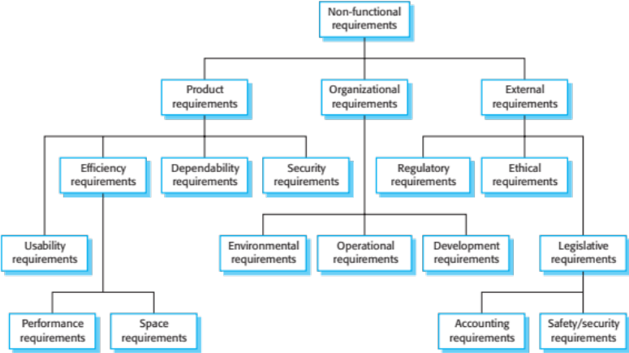
- Please describe all metrics for specifying nonfunctional requirements.
Property | Measure
Speed | Processed transactions per second  User per event response time  Screen refresh time.
Size | Mbytes  Number of help frames
Ease of use | Training time  Number of help frames
Reliability | Mean time to failure  Probability of unavailability  Rate of failure occurrence  Availability
Rebustness | Time to restart after failure  Percentage of events causing failure  Probability of data corruption on failure.
Portability | Percentage of target dependent statements  Number of target systems.

